**EXPERIMENT 2.3**

**NAME: Yash Gupta UID: 20BCS5009**

**SECTION: 709 A Sub: Software Engineering**

**Aim:**

1. Design a Sequence and collaboration diagram of an Online Exam System
2. Design a Sequence and collaboration diagram of School Management System

**Requirement Analysis:**

* Software Requirement:

Digram.net

Google Chrome

* Hardware Requirement:

Computer

Internet

1. **Design a Sequence and collaboration diagram of an Online Exam System**

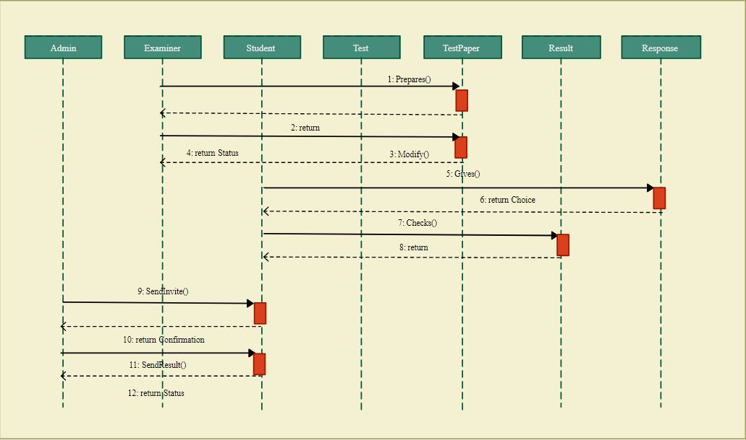

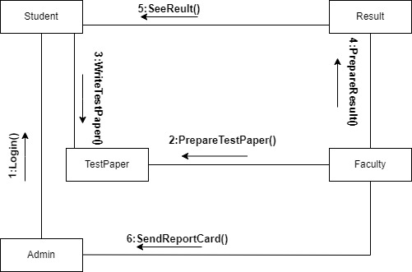

1. **Design a Sequence and collaboration diagram of School Management System**

